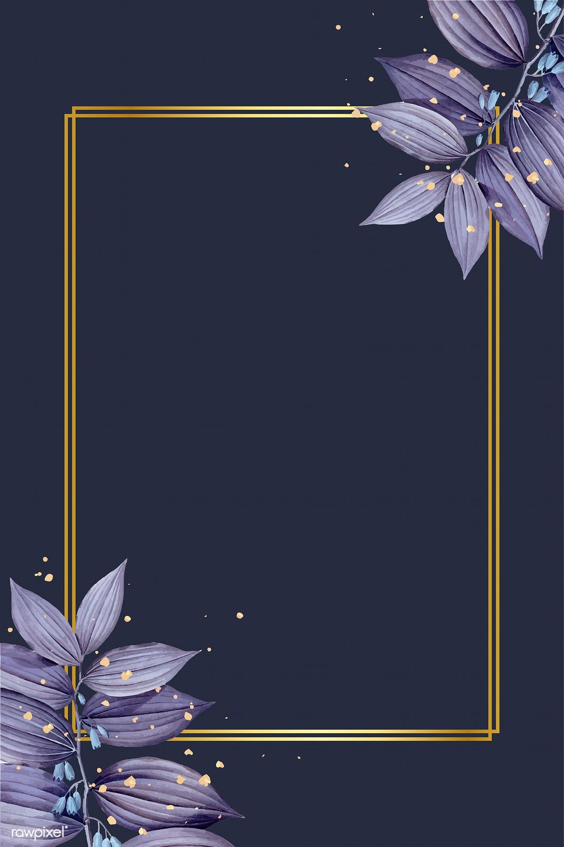

Hello there,

Beautiful!

I know today isn´t a specific holiday or a special occasion(or wait,

it isn´t right?) – but anyways, I just wanted to tell you how special

you are and how much I appreciate everything that you do for us.

Why you ask ? Just because….

With Love,

Your Very Lucky Husband